DECLARATION
I do hereby declare that this Project submitted in partial fulfilment of the requirement for the Bachelor of technology in the Department of Information Communication Technology Huye College, is my original work and has not previously been submitted elsewhere. Also, I do declare that a complete list of references is provided indicating all the sources of information quoted or cited.

Name: MUHIRWA David
Reg No: 23RP00538
Signature:
Date:

DECLARATION
I/we confirm that the work reported in this research project was carried out by David MUHIRWA under my supervision and it has been submitted with my approval as the GIP supervisor.

Name: Dr. Egide NKURUNZIZA

Signature:

Date:

APPROVAL
This is to certify that the project titled SMART MANHOLE CORE carried out by MUHIRWA David have been read, checked and approved for meeting part of the requirements and regulations governing the award of the bachelor of technology in Information Communication Technology of Huye College, Rwanda.

Dr. Egide NKURUNZIZA | Date & signature
(Project Supervisor)
Mr. Patrick NDIZEYE  (HOD) | Date & signature

DEDICATION
I dedicate this final project to:
Almighty God,
My beloved family,
All my close friends who have contributed on this work,
The entire teaching staff who have supported me during my studies,
My supervisor for the guidance and support,
The Government of Rwanda for promoting technology, which has accelerated the development of our country.

ACKNOWLEDGEMENT
In completing this graduate project, I have been fortunate to have help, support and encouragement from many people. I would like to acknowledge them for their cooperation.
First and foremost, deeply thankful to my supervisor Dr. Egide NKURUNZIZA for his wonderful guidance during this project works in field of ICT.
I am also thankful for his continuous feedback and encouragement throughout this project work. His broad knowledge and hardworking attitude have left me with very deep impressions and they will greatly benefit me throughout my life.
I would like to express my thanks to the lectures at Huye College for providing us with capability of IT skills that helped us a lot during the realization of this project research. Also I can’t forgot to extend my heartfelt gratitude for the exceptional support and expertise to the company supervisor and the whole team of BYTEGENIE Limited provided throughout the development of my capstone project.
All in all, I have a great pleasure to thank my lovely Parents for everything they facilitated when I was carrying out my studies, their encouragement, efforts and responsibilities they have taken for me and here I am standing as graduate students.

ABSTRACT
A manhole is an access point to underground utilities such as sewers, water pipes, and telecommunication cables. In most of the countries including Rwanda, manholes play a critical role in safeguarding essential infrastructure water pipes and fiber optic cables. These unseen underground chambers hold the key to delivering vital services to citizens. However, current practices for manhole protection and management seem inadequate where the technical teams working hard to restore services over a long period due to the unknown manhole that had met the issue. From the service provider's problems mentioned fiber optics cables are always damaged while building new infrastructure. It is important to design the system which will provide a way of allowing the telecommunication company to record the geographical location of all manholes, to monitor the open/closed status of manhole covers and detect waste accumulation in a manhole. This system will be known as SMART MANHOLE CORE.
This system should provide a clear picture of manhole locations and their status (open/closed, potential blockages). Each manhole could house a small embedded device with sensors. Track the manhole's geographical location. Detect if the manhole cover is open or closed, measure the distance above the manhole, potentially indicating blockage by debris.

TABLE OF CONTENTS

Contents
DECLARATION I
DECLARATION II
APPROVAL III
DEDICATION IV
ACKNOWLEDGEMENT V
ABSTRACT VI
Contents VII
LIST OF ABBREVIATION X
LIST OF FIGURES XI
LIST OF TABLES XII
CHAPTER 1: GENERAL INTRODUCTION 1
1.0. Introduction 1
1.1. Background of the study 1
1.2. Problem statement 2
1.3. Purpose of the study 2
1.4. Research objectives 2
1.4.1. General objective 2
1.4.2. Specific objectives 2
1.5. Research questions 3
1.6. Scope of the Study 3
1.7. Significance of the study 3
1.8. Methodology 3
1.9. Organization of the report 5
CHAPTER 2: LITERATURE REVIEW 6
2.1. Introduction 6
2.2. Concepts, opinions, and ideas from authors/experts 6
2.3. Theoretical perspectives 7
2.4. Related study 7
2.4.1. First literature 8
2.4.2. Second literature 8
CHAPTER 3: DATA COLLECTION, PRESENTATION AND ANALYSIS OF RESULT 9
3.0. Introduction 9
3.1. Research Design 9
3.1.1. Justification 9
3.2. Research Population 10
3.3. Sampling Size 10
3.3.1. Sampling techniques 10
3.4. Research Instrument 10
3.4.1 Choice of the research instrument 10
3.5. Data Gathering Procedures 11
3.6. Data analysis and interpretation 12
3.7. Ethical considerations 12
3.8. Limitations of the study 12
3.9. Description of the current system 13
3.10. Proposed System 13
3.10.1. Description of the proposed system 13
3.10.2. Network Diagram 13
3.10.3. System Architecture Diagram 14
3.10.4. Activity Diagram 15
3.10.5. Sequence Diagram 15
3.10.6. Class Diagram 16
3.10.7. Data dictionary 18
CHAPTER 4: IMPLEMENTATION 19
4.1 Introduction 19
4.2 Description of technology and tools used 19
4.2.1. Google Map 19
4.2.2 MySQL Database 19
4.2.3. Php 20
4.2.4. Arduino Code 20
4.3 Hardware Tools Requirement 20
4.3.1. Node MCU ESP8266 20
4.3.2. Jump wires 21
4.3.3. Breadboard 21
4.3.4. Tilt sensor 22
4.3.5. Ultrasonic sensor 22
4.3.6. Resistor 23
4.3.7. Transistor (BC337) 23
4.4 Screen Shots 24
4.4.1. Login page 24
4.4.2. Dashboard 24
4.4.3. View manholes 25
4.4.4. Add new manhole 26
4.4.5. View opened manholes 26
4.4.5. Circuit diagram of the system 26
4.4.6. System operation 27
CHAPTER 5: CONCLUSION AND RECOMMENDATION 28
5.1. Conclusion 28
5.2. Recommendation 28
References 29
Appendix A: Technical Specifications 30
A.1 System Overview 30
A.2 sensor specifications 31
A.3 Communication Module 31
Appendix B 31
B.1 Project timeline 31
B.2. Project budget 32

LIST OF ABBREVIATION
GPS: Global Positioning System
GIS: Geographic Information Systems
RP: Rwanda Polytechnic
DFD: Data Flow Diagram
OS: Operating System
IoT: Internet of things
ERD: Entity Relationship Diagram
MYSQL: My Structured Query Language
ICT: Information Communication and Technology
IPRC: Integrated Polytechnic Regional College
JSON: JavaScript object notation
RDBMS: Relational Database Management System
GUI: Graphical User Interface

LIST OF FIGURES
Figure 1: Smart manhole core network diagram 14
Figure 2: System, architecture diagram smart manhole core 14
Figure 3: Activity diagram for smart manhole core 15
Figure 4: Use case diagram for smart manhole core 16
Figure 5: Class diagram for smart manhole core 17
Figure 6: NodeMCU ESP8266 21
Figure 7: Jump wires 21
Figure 8: Breadboard 22
Figure 9: Tilt sensor 22
Figure 10: Ultrasonic sensor 22
Figure 11: Resistor 23
Figure 12: Transistor (BC337) 23
Figure 13: Login page 24
Figure 14: Dashboard for manhole management system 24
Figure 15: Viewing manhole registered 25
Figure 16: Viewing manhole on Google map 25
Figure 17: Adding a new manhole 26
Figure 18: Tracking opened manholes 26
Figure 19: Circuit diagram for smart manhole core 27

LIST OF TABLES
Table 1: data dictionary 18
Table 2: sensor specifications 31
Table 3: communication module specification 31
Table 4: project timeline for the SMART MANHOLE CORE system 32
Table 5: project budget for the SMART MANHOLE CORE system 32

CHAPTER 1: GENERAL INTRODUCTION

Introduction
In today's Rwanda, manholes play a critical role in safeguarding essential infrastructure water pipes and fiber optic cables. These unseen underground chambers hold the key to delivering vital services to citizens. However, current practices for manhole protection and management seem inadequate. This project proposes an innovative embedded system to address these shortcomings.
The main idea of this work is to provide ease and comfort to the service provider and customers in general, where the system will provide a way of allowing the service provider to add new manholes, record the geographical location of all manholes, the system is ready to monitor open/closed status of manholes covers, and detect waste accumulation in a manholes and also for the customer to keep served well without data disruption.
SMART MANHOLE CORE is a smart system with the core functionality of managing manholes. The system incorporates intelligence through sensors, data processing, and potential automation. Could be the physical embedded device installed within the manhole or the central software platform that manages data from multiple manholes.

Background of the study
Rwanda's growing population and reliance on efficient infrastructure necessitate robust management of underground utilities. Manholes provide crucial access points for maintenance and repairs. However, poorly maintained or unprotected manholes can lead to data leaks and disruptions, Damage to fiber optic cables, impacting internet connectivity, and Safety hazards for pedestrians and motorists. That’s where we come here to advance performance. So, we’re always on the lookout for new ways to improve. Our focus is on providing effective solutions and offering better management for those unseen chambers.

Problem statement
After observing the existing system and the way the current practices for manhole protection and management are implemented in Rwanda. It’s very difficult to ensure manholes are properly secured and not blocked by waste, Lack of a centralized tracking system for manhole location and status (open/closed), data leaks and disruptions, and Damage to fiber optic cables, impacting internet connectivity

Purpose of the study
The main aim of this study is to improve the efficiency and reliability of underground utility infrastructure in Rwanda by developing a system for better monitoring and management of manholes. This would directly address the challenges of data leakages, damaged cables, and safety hazards.

Research objectives

1.4.1. General objective
An embedded system for comprehensive manhole tracking and management will be designed and developed for using in Kigali city.

1.4.2. Specific objectives
- Design a system to record the geographical location of all manholes within the study area.
- To monitor the open/closed status of manhole covers.
- To detect waste accumulation in a manhole.
- To develop a user interface for visualizing manhole location, status, and historical data.
- Design an alert system to notify authorities of open manholes or potential blockages.
- Improve the security of the system.

Research questions
- How can existing technologies be optimized to develop a low-power, efficient manhole monitoring system that effectively collects and transmits data for improved infrastructure management?
- What data visualization and integration strategies can be employed to enhance user experience and system compatibility within the existing infrastructure management framework?

Scope of the Study
This system is limited to develop a smart manhole that track the manhole location, analyzing for real-time manhole status and user interface for data visualization.

Significance of the study
This Smart Manhole Core holds significance for telecommunication companies to enhance the protection of fiber optic cables for better internet connectivity, government agencies to improved infrastructure management and public safety and citizens, Reliable access to stable internet connection. Moreover, this research support the country and telecommunication company in advancing towards a more technologically advanced future.

Methodology
- Study Area
This project will be conducted in Kigali city an area with more existing underground utilities and manholes.
- Study Design
The design and implementation of this project of SMART MANHOLE CORE is achieved as follows:
- Prototyping system: building a functional version of the smart manhole core with its embedded software and sensors.
- Pilot testing: installing the smart manhole core in a small number of manholes within the study area to assess its effectiveness in real-world conditions.
- Data collection and analysis: Gathering data from the sensors (manhole status, waste accumulation) and analyzing it to evaluate the system’s performance.
- Data collection methods and procedures
To effectively implement the SMART MANHOLE CORE, the following data collection methods and procedures will be employed:
- Surveying and Mapping: Conduct comprehensive surveys using GPS and mapping technologies to locate existing manholes and assess their condition.
- Interviews and Focus Groups: Engage with stakeholders, including utility workers, city planners, and community members, through interviews and focus groups to gather insights into current challenges and potential solutions.
- Observation and Documentation: Document physical conditions of manholes, noting issues such as blockages or poor maintenance, through visual inspections and data logging.
- Ethical considerations
In developing an innovative embedded system for manhole management in Rwanda, several ethical considerations must be addressed. Privacy and Security to ensure that data collection methods do not compromise the privacy of individuals or the security of sensitive infrastructure information. Community Impact to consider the potential impact on local communities, ensuring that the project benefits without causing harm. Transparency to Communicate openly about the project's objectives, methodologies, and potential outcomes with stakeholders, including residents and government officials.

Organization of the report
This system is subdivided into five chapters:
Chapter one: general introduction and background of study, contains introduction to the study that represents the introduction, background of the study, problem statement, objectives, scope of the project, interest of the project, and Limitations of the project
Chapter two: literature review, this chapter is a discussion and explanation of different terms that will be used in this project and how they can relate to and operate with other systems.
Chapter three: data collection, presentation and analysis of results, this how the data shall be presented, analyzed, and interpretation of results. The presentation format of data is designed basing on the data collection instruments.
Chapter four: design specification (result and discussion), this Focuses on the implementation of the v system, technologies used and the results whereas.

Chapter five: conclusion, and recommendations, this chapter is all about satisfaction and sustainability as well as the function if it if is the same as we desired during idea creation.

CHAPTER 2: LITERATURE REVIEW

Introduction
This chapter is written to consider the critical points of current knowledge including substantive findings as well as theoretical and methodological contributions to a particular topic. The main goals are to situate the current study within the body of literature and to provide context for the particular reader. (sciencedirect, 2016)
As the topic mentioned smart manhole core is a smart system with the core functionality of managing manholes. The system incorporates intelligence through sensors, data processing, and potential automation. Could be the physical embedded device installed within the manhole or the central software platform that manages data from multiple manholes.
In today's Rwanda, manholes play a critical role in safeguarding essential infrastructure water pipes and fiber optic cables. These unseen underground chambers hold the key to delivering vital services to citizens. However, 4.25 Million internet customers in Rwanda have been using the internet and more households in Kigali get fiber optic coverage in the range of 11,000 households while they target 20,000. (Bizimungu, 2018) The major issue for now that progress it’s the cuts of the internet cables in those different manholes, where the technical teams working hard to restore services for a long period due to the unknown manhole that had met the issue. This project proposes an innovative embedded system to address all these shortcomings (Kemp, 2023)

Concepts, opinions, and ideas from authors/experts
In urban areas, such as cities, the situation of ecological conditions should be improved with the rising global demand for sustainable development. It is, therefore, necessary to rebuild the streets in an environmentally friendly manner to ensure the sustainability of urban manhole covers and at the same time achieve the sustainability of urban areas. With the aim of urban redevelopment, urban manhole covers' functioning improvement, and pushing for sustainable urban development methods, the study introduces the environmental design of urban manhole covers and gives suggestions for future designs in developed countries. The knowledge, processing, and use of sensors, and the utility of artificial intelligence in a manhole will be connected through mentioned ways. It may consist either of the physical units built in the manhole or central software, which is responsible for the joint management of the data collected from many manholes. (Guo, 2024)

Theoretical perspectives
This research strengthens urban infrastructure management through the application of IOT principles. This project to contribute to improving service delivery, reducing disruptions, and promoting the development of smarter cities in two main key theoretical perspectives:
- Urban Infrastructure Management: This theory has a strong focus on the competent and sustainable control of the physical assets of a city, which includes underground infrastructure such as manholes. This research provides a solution to the limitations of current methods, the unknown manhole problems are the major cause of service disruptions and long recovery times. The introduction of an IOT Leap smart manhole core system to evaluate the potential of technology in enhancing data collection, monitoring, and maintenance processes for manholes.
- The Internet of Things (IoT) and Smart Cities: This concept investigates how ordinary, concrete items can be fitted with sensors and linked to a network to retrieve and share information. The project, in addition to deploying embedded devices and sensors within manholes, epitomizes this concept. The smart manhole core system enables a smart city and it uses IOT devices to provide a real-time flow of data to qualify the manhole status and best optimal management of the infrastructure.

Related study
The purpose of the literature review is to gain an understanding of the existing research and debates relevant to a particular topic or area of study. Briefly, in this literature review, we will look at different literature, important concepts, research methods, and experimental techniques used during the research for manhole cover in Rwanda. (westernsydney, 2017)

2.4.1. First literature
In 2008, the government of Rwanda embarked on a nationwide roll-out of fiber optic as a backbone infrastructure for broadband. This optic fiber connected different parts of the country and provided high-capacity cross-border links with onward connectivity to submarine cables. Where they are now focusing on providing technical support to ensure all users have uninterrupted Internet connectivity. We are also prioritizing infrastructure development to bring Internet connectivity to rural towns and villages throughout Rwanda. However, challenges have arisen, notably concerning the security of fiber optic manholes. Unsecured manholes pose risks to the integrity and reliability of the network, potentially leading to the service disruptions and operational inefficiencies. Addressing these security concerns is crucial for safeguarding the benefits of Rwanda’s extensive broadband infrastructure investment. (The UN agency for digital technologies, 2020)

2.4.2. Second literature
In our neighbor countries like Kenya, the journey in deploying fiber optics networks began with strategic investments aim at the bridging the digital divide and promoting access to affordable broadband services. However, challenges persist, including issues related to the infrastructure security. Instances of vandalism and theft of fiber optic cables have been reported, affecting service reliability and operational costs. Effort to mitigate these challenges involve collaborations between government agencies, private sector stakeholders, and local communities to enhance security measures and ensure sustainable infrastructure management. (worldbank, 2020)

CHAPTER 3: DATA COLLECTION, PRESENTATION AND ANALYSIS OF RESULT

3.0. Introduction
Urban infrastructure, particularly drainage systems, faces increasing strain due to rapid urbanization. Manholes, as critical components, often suffer from issues like blockages and overflows. This research introduces a smart manhole core system to address these challenges by collecting, analyzing, and utilizing data for improved manhole management. By harnessing IoT technology, the system gathers comprehensive data on manhole conditions, enabling proactive maintenance and efficient resource allocation. This report details the data collection methods, presentation techniques, and analysis of results from the Smart Manhole Core System.

3.1. Research Design
This study aims to evaluate the effectiveness of a smart manhole core system in improving manhole management. A quasi-experimental design will be employed to assess the system's impact on data collection, monitoring, and maintenance practices.
- Quasi-experimental: If you plan to introduce the smart manhole core system in a controlled environment (e.g. Gikondo sector) and compare its performance to a similar area without the system, a quasi-experimental design would be suitable. This would allow you to measure the impact of the system on various parameters like manhole blockages, water levels, and maintenance costs.

3.1.1. Justification
A quasi-experimental design is the most appropriate for this study due to the following reasons:
- Lack of Random Assignment: Randomly assigning manholes to a control group and an experimental group is impractical and unethical. Existing manhole conditions necessitate a non-randomized approach.
- Real-world Conditions: The study aims to evaluate the system in a real-world setting, where controlled conditions are not feasible.
- Evaluation Focus: The primary goal is to assess the effectiveness of the smart manhole core system in improving manhole management, rather than establishing causal relationships.

3.2. Research Population
In June 2013, the government of Rwanda and KT entered into public private partnership to install a wide-ranging high-speed broadband network and expand the nation’s online services essential for Rwanda’s goals in the ICT sector. So accordingly to the way the internet is needed by large number of citizens that is why we had considered that sector. Where we involve in the maintenance and management of manholes. And Responsible for urban infrastructure development and management. The research population consists of all the manholes in Kigali city where the smart manhole core system will be deployed. (KTN RWANDA NETWORKS, 2022)

3.3. Sampling Size
A major purpose of doing research is to infer or generalize research objectives from a sample to larger population. The process of inference is accomplished by using statistical methods based on probability theory. A sample is a subset of the population selected, which is unbiased representative of the larger population. The population selected on our project was the citizens of Gikondo sector in Kigali city.

3.3.1. Sampling techniques
To ensure reliable and valid inferences from a sample, probability sampling technique is used to obtain unbiased results. The sampling technique employed will be Stratified Sampling by Dividing Rwanda into strata (e.g., urban vs. rural areas) and selecting samples proportionally from each stratum to ensure representation. And convenience sampling by Accessing manholes that are readily available and accessible for data collection purposes.

3.4. Research Instrument

3.4.1 Choice of the research instrument
In this project there are some of the materials and methods used to search for data, we were just visited to the field as where source data are appeared, and also keep in touch with the people work on those institution. For the secondary data we had just use the internet to read for exist books and journal related to our project. Those are techniques of collecting data such as: (questionpro, 2021)
The research instrument used will include:
Questionnaires
Questionnaires is one of the most common methods of collecting information from individuals or a group of people. Structured to gather quantitative data on manhole conditions, maintenance practices, and perceived challenges.
Interview
Interviewing is one of the most common methods of collecting information from individuals. There are various types of interviews that are used to collect data. Interviews can be conducted in a variety of ways; for example, by telephone or as a face-to-face interview using an interview. Semi-structured to explore qualitative insights from stakeholders regarding their experiences and recommendations for improvement.
Schedule to guide your questions. In this study, we have used telephone and face to face interview with the telecommunication workers (engineers & network administrator) and some customers on how they see the existing manhole and how can them receive the new smart manhole. The information gotten from this interview was analyzed with the aim of seeing if new system will be accepted.
Observation
According to associate prof. Melanie Bryant, Observation is a method of data collection in which researches observe within a specific research field. It is sometimes referred to as an unobtrusive method. In this study as a Rwandan, I have studied and observed the way the manhole are protected and managed in Gikondo sector.

3.5. Data Gathering Procedures
The data gathering procedure will involve:
Survey Deployment: Conducting physical surveys to inspect and document the condition of selected manholes, including GPS tagging for spatial mapping.
Interviews and Focus Groups: Facilitating discussions with stakeholders to gather insights on perceptions, challenges, and potential solutions related to manhole management.
Documentation: Recording observations and data findings using digital tools and standardized forms for consistency.

3.6. Data analysis and interpretation
In order to discuss data analysis and the role it plays in advanced technologies within Rwanda's infrastructure management context as developing countries; we must first understand the data that is being collected and analyzed. There is data being collected on the process and procedures of the business side of infrastructure sector, but there is also an enormous amount of data being gathered, stored and analyzed. The use of those data to be analyzed allows for improvements to the Infrastructure Management and Technology Adoption and more.

3.7. Ethical considerations
In developing an innovative embedded system for manhole management in Rwanda, several ethical considerations must be addressed. Privacy and Security to ensure that data collection methods do not compromise the privacy of individuals or the security of sensitive infrastructure information. Community Impact to consider the potential impact on local communities, ensuring that the project benefits without causing harm. Transparency to Communicate openly about the project's objectives, methodologies, and potential outcomes with stakeholders, including local residents and government officials.

3.8. Limitations of the study
This project will be limited by lack of support Telecommunication Company for starting approving this system to be used on different manholes. Moreover, this study might be limited by budgetary constraints for hardware and software implementation, Access to existing infrastructure data and collaboration with relevant authorities, Timeframe for development and testing of the embedded system. This system requires the active internet connection to ensure that all requested submitted to the intended destination.

3.9. Description of the current system
The current system for manhole management lacks real-time data collection, effective monitoring, and integrated communication, resulting in inefficiencies and increased risk of infrastructure damage and service disruptions. Manholes are typically mapped using traditional methods, such as manual surveys. This data is often stored in physical records or basic digital formats, which can be prone to inaccuracies and is not updated frequently. Information regarding the status of manhole covers (whether they are open or closed) is generally tracked through periodic physical inspections. There is no real-time monitoring, leading to potential delays in identifying and addressing issues.

3.10. Proposed System

3.10.1. Description of the proposed system
After analyzing the current traditional system of managing and monitoring manhole, the proposed SMART MANHOLE CORE system is designed to enhance the management and protection of manholes, which are crucial for safeguarding essential infrastructure such as water pipes and fiber optic cables. This system integrates embedded devices with sensors in each manhole to provide real-time data on geographical location, cover status (open or closed), and waste accumulation levels. By tracking the precise location of each manhole, monitoring its operational status, and detecting potential blockages caused by debris, the SMART MANHOLE CORE enables more efficient service management and preventive maintenance. This proactive approach helps minimize damage to infrastructure, reduces the time required for technical teams to address issues, and improves overall service reliability.

3.10.2. Network Diagram
Network diagram shows how different devices, sensors, and systems are connected within the SMART MANHOLE CORE project. It maps out the physical and logical connections between manholes, central servers, and other networked devices such as user terminals or mobile devices.
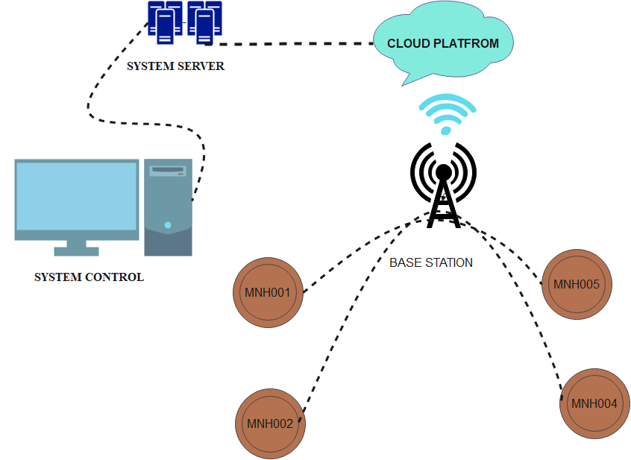
Figure 1: smart manhole core network diagram

3.10.3. System Architecture Diagram
A system architecture diagram provides a high-level overview of the entire system, showing the relationship between different components. For SMART MANHOLE CORE, this could include hardware components like sensors, the embedded device, communication modules, and software components like databases, processing units, and user interfaces.
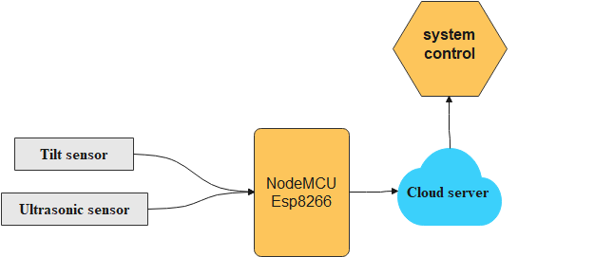
Figure 2: system, architecture diagram smart manhole core

3.10.4. Activity Diagram
An activity diagram shows the flow of activities or processes within the system. For the SMART MANHOLE CORE project, this could depict how data is collected from manhole sensors, processed, and then used to trigger alerts or updates in the system.
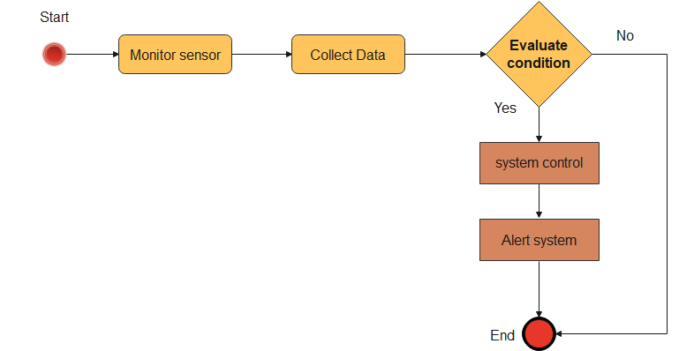
Figure 3: Activity diagram for smart manhole core

3.10.5. Sequence Diagram
A sequence diagram shows how objects within the system interact with each other over time. It’s useful for understanding the sequence of operations in a specific process. The sequence diagram can represent how various components interact to monitor and manage the manhole.
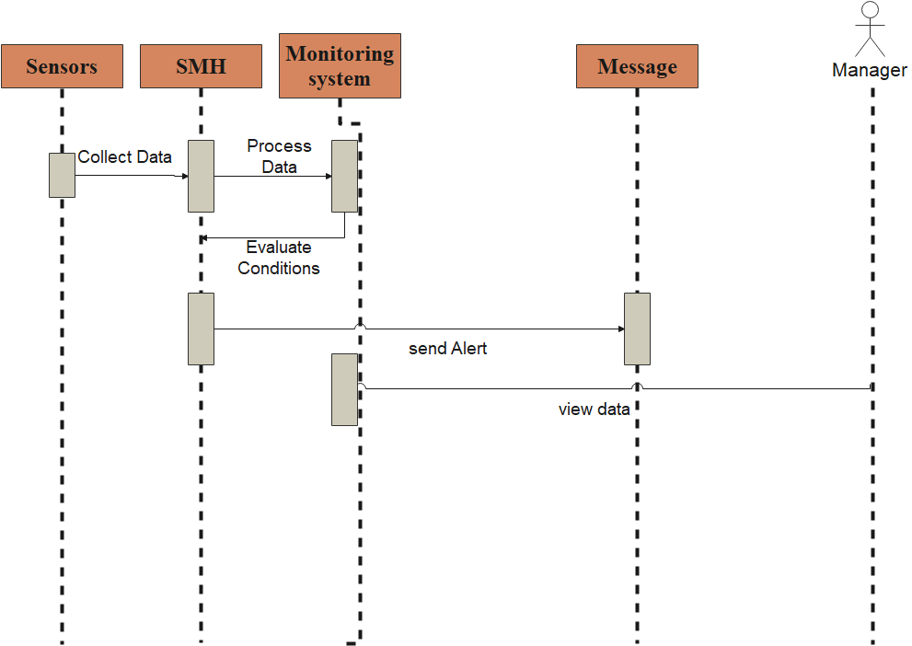
Figure 4: Use case diagram for smart manhole core

3.10.6. Class Diagram
A class diagram outlines the structure of the system by showing its classes, attributes, methods, and relationships between classes. It is a blueprint of the system's object-oriented structure.
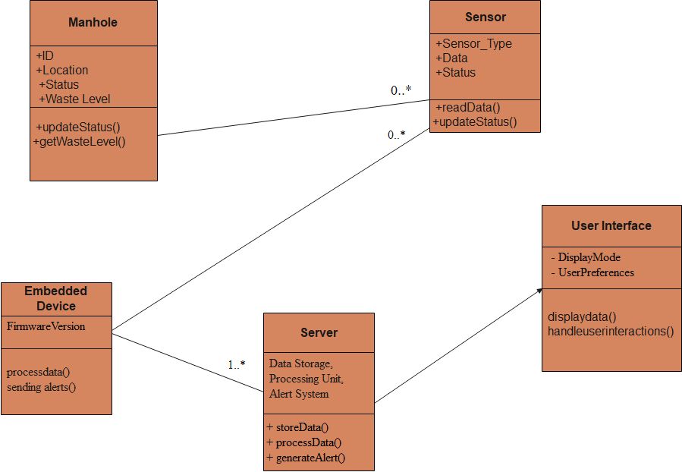
Figure 5: Class diagram for smart manhole core
Class diagram symbols
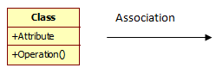
Relationships such as "Manhole has Sensors," "Server processes data from Embedded Device," and "User Interface connects to Server" would be shown as lines connecting these classes.

3.10.7. Data dictionary
Below is the data dictionary that describes the data objects, it can be used as reference for the analysis of the database.
CLASS | ATTRIBUTE | DATA TYPE | CONSTRAINT | DESCRIPTION
Manhole | ID | int | Primary key | Manhole identifier.
 | Location | String | Not null | Geographical location
 | locator | Float | Not null | Longitude and latitude
Status | ID | int | Primary key | Unique identifier for status
 | manholeid | int | Not null | Unique identifier for manhole
 | function | string | Not null | Data value(open or close)
 | ID | int | Primary key | Unique identifier for user
User | userame | String | Not null | username
 | Phone No | Integer | Not null | Phone Number
 | Password | String | Not null | password
 | address | String | Not null | address

Table 1: data dictionary

CHAPTER 4: IMPLEMENTATION

Introduction
This chapter provides a detailed exploration of implementation for the SMART MANHOLE CORE system, designed to enhance the management and protection of manholes. It encompasses technology and tools necessary to develop a comprehensive and effective solution for manhole management and monitoring. The SMC system aims to address the challenges associated with manhole protection, location, and status, as well as waste accumulation, by providing real-time data and insights to telecommunication companies.

Description of technology and tools used

4.2.1. Google Map
Google Maps is a digital street map that is nourished by information from Street View cars adapted to capture images at street level and the GPS signal of users’ mobile devices. Google map will be providing critical geospatial visualization and interactive features. Here’s a detailed breakdown of how Google Maps will be utilized in the system:
- Maps Embed API: Allows embedding interactive Google Maps directly into your web application. This will be used to display a map showing the locations of all manholes.
- Geocoding API: Converts addresses or location descriptions into geographic coordinates (latitude and longitude), ensuring accurate placement of manholes on the map.
- Reverse Geocoding API: Converts geographic coordinates back into readable addresses, which can help in verifying locations and providing context for each manhole.

4.2.2 MySQL Database
A database is a structured collection of data. It may be anything from a simple shopping list to a Picture gallery or the vast amounts of information in a corporate network. To add, access, and process data stored in a computer database, you need a database management system such as MySQL Server. Since computers are very good at handling large amounts of data, database management systems play a central role in computing, as standalone utilities, or as parts of other applications (Oracle, 2015).

4.2.3. Php
PHP will be used for server-side scripting and backend development. PHP will used in different features such as Database Management to handle database interactions to store and retrieve manhole data, Data Processing to process data sent from embedded sensors and manage it efficiently and Web Integration to handle the integration of manhole data with Google Maps, enabling dynamic updates and interactive features on the web platform.

4.2.4. Arduino Code
Arduino code also known as an Arduino sketch, is written in C++ with additional special methods and functions. It consists of two main parts: setup code and loop code. Arduino code will be used to program the embedded devices placed in manholes. Arduino will interface with sensors to monitor the status of manhole covers (open/closed) and detect potential blockages or waste accumulation. Arduino will send data to the central server, where it will be processed and displayed.

Hardware Tools Requirement

4.3.1. Node MCU ESP8266
The Node MCU (ESP8266) is a microcontroller with an inbuilt Wi-Fi module. It is a device with a total of 30 pins out of which 17 are GPIO pins, these GPIO pins are connected to various sensors to receive data from the sensors and send output data to the connected devices. The Node MCU (ESP8266) has 128KB of RAM and 4MB flash memory storage to store programs and data. The code is dumped into the Node MCU (ESP8266) and is stored in it. Whenever the Node MCU (ESP 8266) receives input data from various sensors, it crosschecks the data received and the data stored in it. Depending on the data received it sends a pulse to the Relay Module
Which in-turn acts as a switch to on or off the pump? The operating frequency of the Node MCU (ESP8266) ranges from 80 to 160 MHZ, and the operating voltage ranges from 3 to 3.6V. The range of the Wi-Fi module presents in the Node MCU (ESP8266) ranges from 46 (indoors) to 92 (Outdoors) Meters.
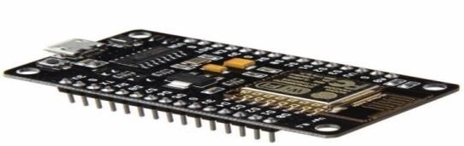
Figure 6: NodeMCU ESP8266

4.3.2. Jump wires
Jump wires (also called jumper wires) for solder less breadboard can be obtained in ready-to-use jump wire sets or can be manually manufactured. The latter can become tedious work for larger circuits. Ready to- use jump wires come in different qualities, some even with tiny plugs Attached to the wire ends. Jump wire material for ready-made or homemade wires should usually be 22 AWG (0.33 mm2) solid copper, tin-plated wire - assuming no tiny plugs are to be attached to the wire ends. The wire ends should be stripped 3⁄16 to 5⁄16 in (4.8 to 7.9 mm). Shorter stripped wires might result in bad contact with the board's spring clips (insulation being caught in the springs). Longer stripped wires increase the likelihood of short-circuits on the board. Needle-nose pliers and tweezers are helpful when inserting or removing wires, particularly on crowded boards.
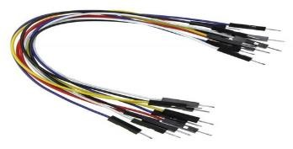
Figure 7: Jump wires

4.3.3. Breadboard
A Breadboard is simply a board for prototyping or building circuits on. It allows you to place components and connections on the board to make circuits without soldering. The holes in the breadboard take care of your connections by physically holding onto parts or wires where you put them and electrically connecting them inside the board. (6. Kramer Chen, 2019)
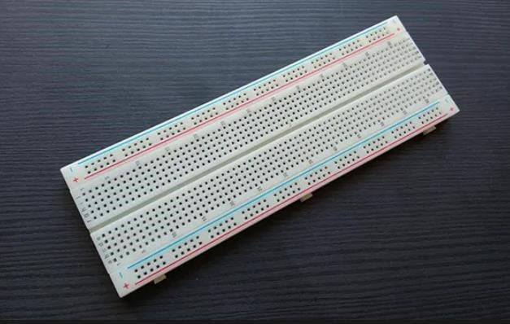
Figure 8: Breadboard

4.3.4. Tilt sensor
Tilt sensors, also known as inclinometers, are devices used to measure the tilt or inclination of an object with reference to gravity. They produce an electrical signal that varies with angular motion and are used in various applications. Tilt sensors are devices that produce an electrical signal that varies with an angular movement. These sensors are used to measure slope and tilt within a limited range of motion. Sometimes, the tilt sensors are referred to as inclinometers because the sensors just generate a signal but inclinometers generate both readout and a signal. (Elprocus, n.d.)
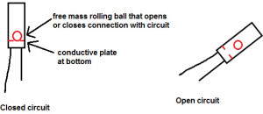
Figure 9: Tilt sensor

4.3.5. Ultrasonic sensor
An ultrasonic sensor is an electronic device that measures the distance of a target object by emitting ultrasonic sound waves and converting the reflected sound into an electrical signal. These sensors are widely used in various industries and fields due to their ability to measure and detect objects or distances without physical contact.
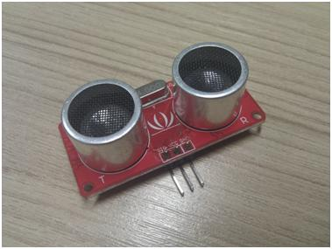
Figure 10: ultrasonic sensor

4.3.6. Resistor
Resistor is defined as a passive electrical component with two terminals that are used for either limiting or regulating the flow of electric current in electrical circuits. The main purpose of resistor is to reduce the current flow and to lower the voltage in any particular portion of the circuit. It is made of copper wires which are coiled around a ceramic rod and the outer part of the resistor is coated with an insulating paint.
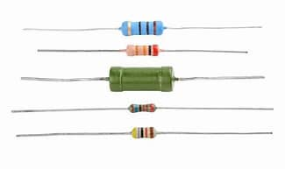
Figure 11: resistor

4.3.7. Transistor (BC337)
BC337 is an NPN transistor mainly used for lower power audio amplification and switching purposes. It contains three terminals known as emitter, base, and collector. The small current chance at the base side is used to produce large current change at the remaining terminals. BC337 transistor is used to switch or amplify electronic signals as well as power. It is composed of semiconductor material generally with a minimum of three terminals to connect an exterior circuit. (BC337 Transistor , n.d.)
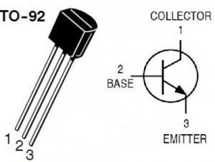
Figure 12: transistor (BC337)

Screen Shots

4.4.1. Login page
The login page for the SMART MANHOLE CORE system serves as the gateway to access the system's features and functionalities. It ensures secure access for authorized users while providing an intuitive interface for ease of use.
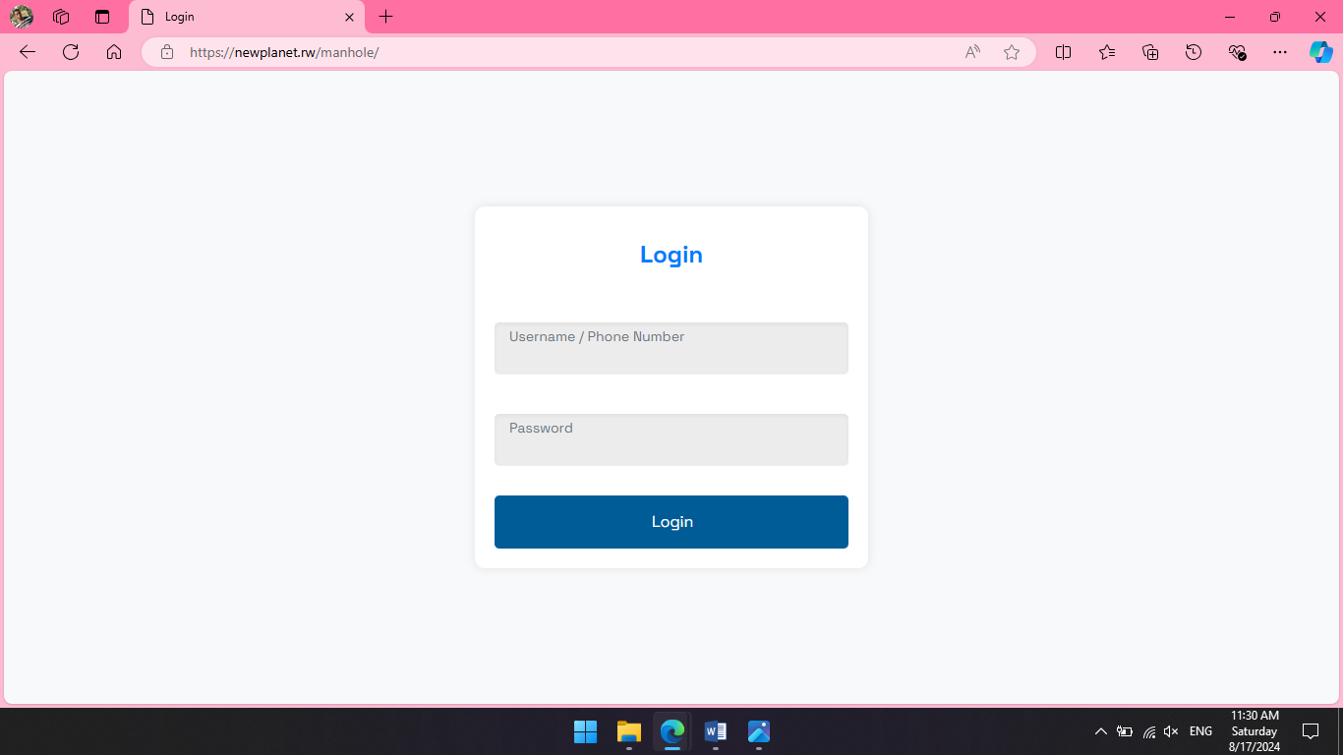
Figure 13: login page

4.4.2. Dashboard
The dashboard for the SMART MANHOLE CORE system is the central interface where users can monitor and manage manholes effectively. It provides a comprehensive overview of manhole statuses, locations, and other critical data, offering an intuitive and interactive experience.
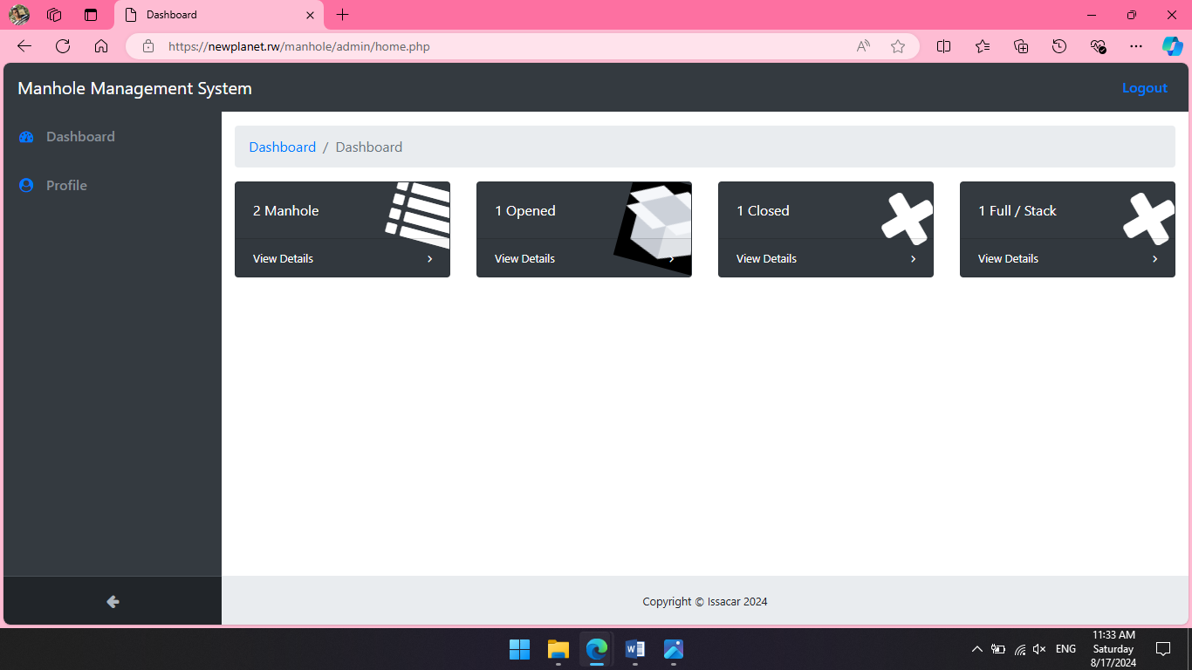
Figure 14: dashboard for manhole management system

4.4.3. View manholes
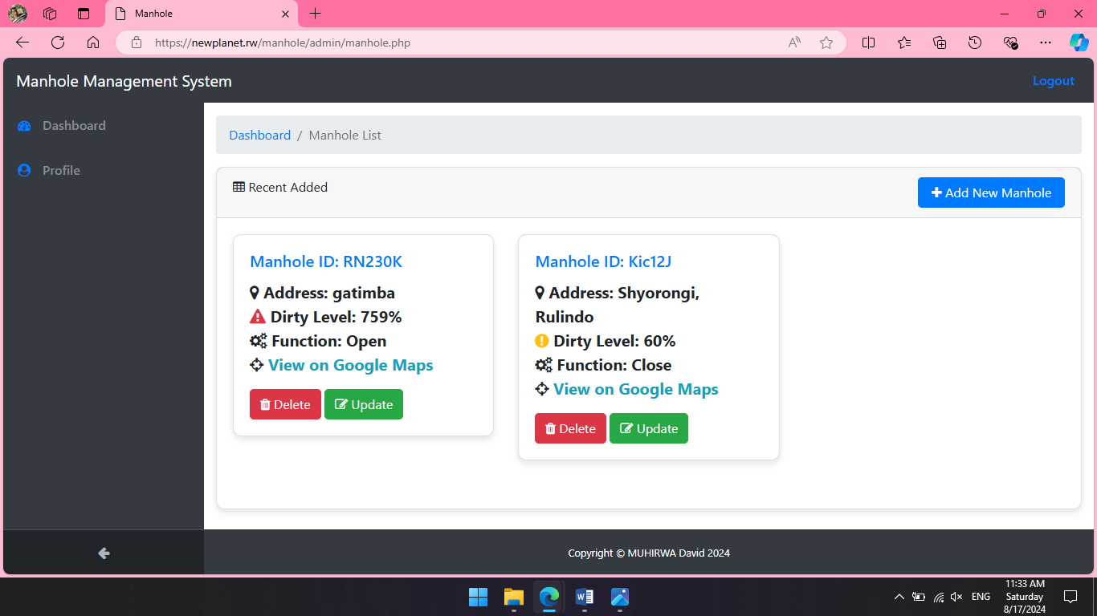
Figure 15: viewing manhole registered
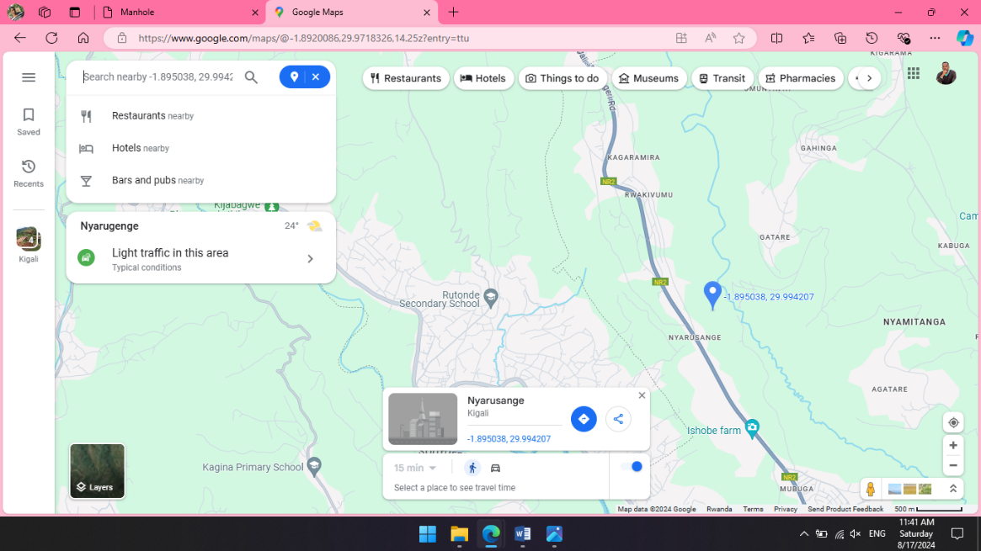
Figure 16: viewing manhole on Google map

4.4.4. Add new manhole
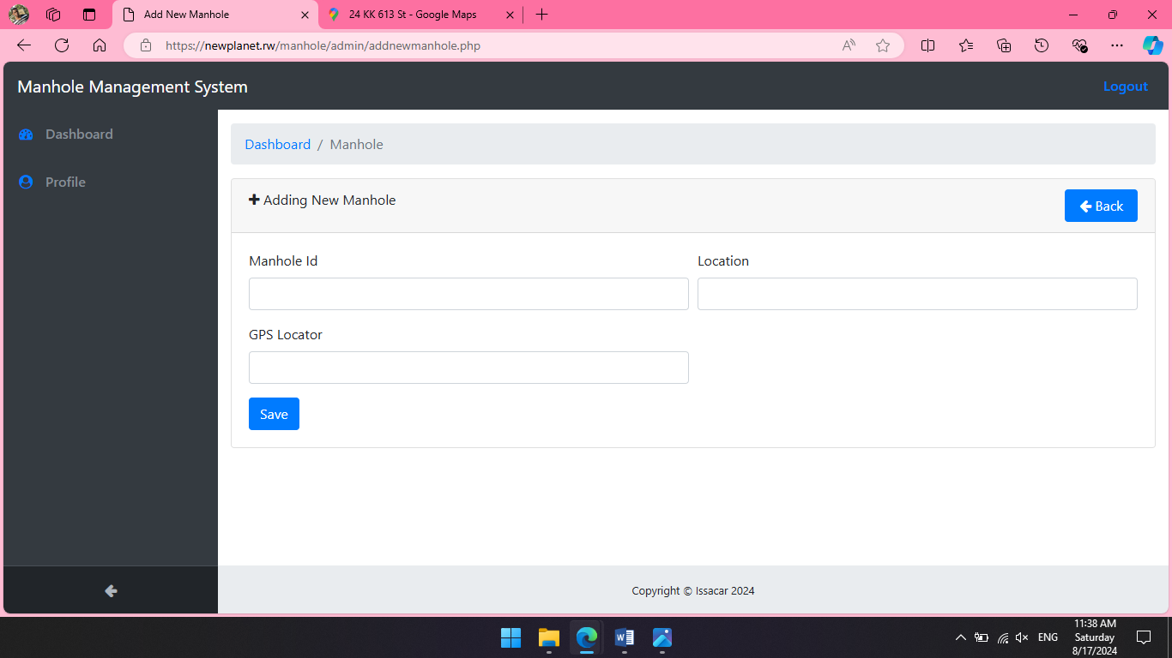
Figure 17: adding a new manhole

4.4.5. View opened manholes
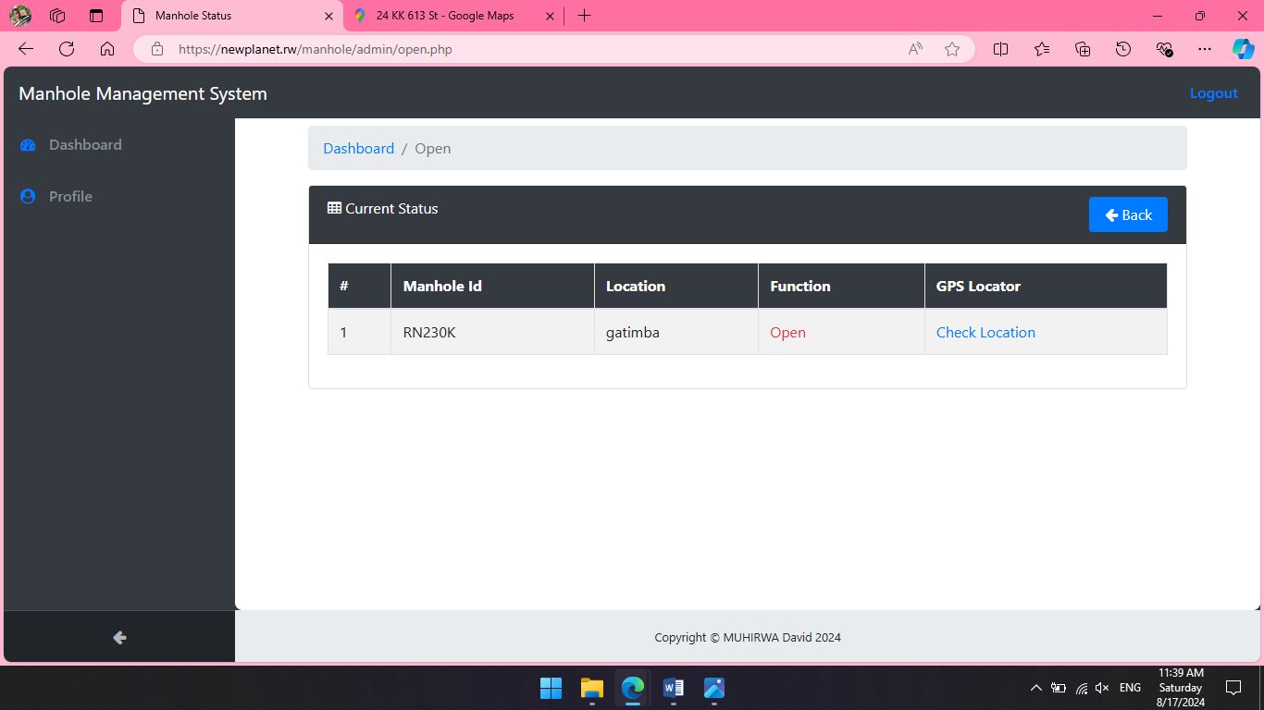
Figure 18: tracking opened manholes

4.4.5. Circuit diagram of the system
Creating a circuit diagram for the SMART MANHOLE CORE system involves detailing how various components interact within the embedded device that monitors the manhole. The circuit will typically include sensors for detecting manhole status and possible obstructions, a microcontroller for processing data, and communication modules to send data to a central server. Below is a circuit diagram representation of how the components are connected
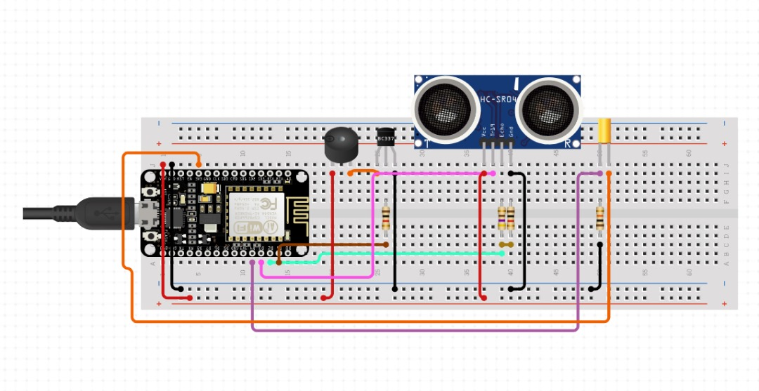
Figure 19: circuit diagram for smart manhole core

4.4.6. System operation
The smart manhole core system operates by using embedded sensors in each manhole to monitor the cover status and detect potential blockages. The system rely pre-defined Google Maps addresses for manhole locations. The microcontroller processes the sensor data and sends status updates to a central server or cloud-based platform via a communication module as Wi-Fi. This data is then integrated with Google Maps to display the real-time locations and conditions of manholes on an interactive dashboard. Users can view manhole statuses, receive alerts, and manage maintenance tasks based on the visual data provided by the system.

CHAPTER 5: CONCLUSION AND RECOMMENDATION

5.1. Conclusion
In conclusion, the SMART MANHOLE CORE project addresses a critical need for enhanced manhole management and protection by integrating advanced monitoring technologies. By equipping each manhole with embedded sensors to track cover status, detect potential blockages, and measure debris accumulation, this system offers real-time insights into the condition of underground infrastructure. Although the system will utilize predefined Google Maps addresses for location tracking, it still provides a comprehensive overview of manhole statuses and locations. This approach not only improves the efficiency of managing essential services but also mitigates the risk of infrastructure damage, particularly to sensitive fiber optic cables. Ultimately, smart manhole core aims to streamline maintenance operations, reduce service interruptions, and ensure the reliability of critical utilities, thereby delivering a significant benefit to both service providers and citizens.

5.2. Recommendation
To optimize the effectiveness of the SMART MANHOLE CORE system, I would like to recommend to integrate a multi-layered data monitoring approach that combines advanced sensor technologies with a robust data analytics platform. Specifically, consider incorporating sensors that measure environmental conditions such as temperature, humidity, and vibration in addition to cover status and distance to detect potential blockages. This comprehensive data collection will provide a more detailed picture of the manhole's condition and help preemptively identify issues before they escalate.
Additionally, ensure that the system includes strong data security measures and regular maintenance protocols to safeguard and maintain the integrity of the collected data. Implementing user training programs and feedback mechanisms will also support effective use and continuous improvement of the system. By adopting these strategies, the SMART MANHOLE CORE system will enhance its ability to manage and protect vital infrastructure, improve service reliability, and reduce the risk of damage to essential utilities.

References
- (n.d.). Retrieved from Elprocus: https://www.elprocus.com/tilt-sensor-types-working-principle-and-its-applications/
- (2016, 11). Retrieved from sciencedirect: https://www.sciencedirect.com/science/article/abs/pii/S1386505616302003
- BC337 Transistor . (n.d.). Retrieved from elprocus: https://www.elprocus.com/bc337-transistor/
- Bizimungu, J. (2018, April 25). More Kigali households get Fibre optic coverage. Retrieved from www.newtimes.co.rw/articles: https://www.newtimes.co.rw/article/151393/News/more-kigali-households-get-fibre-optic-coverage
- Guo, H. (2024). Research on Ecological Design of Intelligent Manhole Covers Based on Fuzzy Analytic Hierarchy Process. Sustainability , 16.
- Kemp, S. (2023, FEBRUARY 14). DATAREPORTAL. Retrieved from www.datareportal.com/: https://datareportal.com/reports/digital-2023-rwanda
- KTN RWANDA NETWORKS. (2022). Retrieved from www.ktrn.rw: www.ktrn.rw/about
- Oracle. (2015). NET applications that access the Oracle Database. https://www.oracle.com/database/technologies/dotnet-odacmsi-downloads.html.
- propatel. (2021). Retrieved from https://www.propatel.com/: https://www.propatel.com/use-case-vs-dfd-difference-in-use-case
- questionpro. (2021). Retrieved from https://www.questionpro.com: https://www.questionpro.com/blog/data-collection/
- Sommerville, I. (2016). software engineering. Pearson Education Limited.
- The UN agency for digital technologies. (2020, May 28). Retrieved from https://www.itu.int/hub: https://www.itu.int/hub/2020/05/in-rwanda-broadband-internet-connects-rural-communities-to-a-bright-future/#:~:text=In%202008%2C%20the%20government%20of%20Rwanda%20embarked%20on,crossborder%20links%20with%20onward%20connectivity%20to%20submarine%20cables.
- westernsydney. (2017). Retrieved from https://www.westernsydney.edu.au: https://www.westernsydney.edu.au/__data/assets/pdf_file/0006/1254786/Literature_review_purpose.pdf
- worldbank. (2020). Retrieved from www.worldbank.org: https://www.worldbank.org/en/country/kenya/publication/kenya-digital-economy-diagnostic

Appendix A: Technical Specifications

A.1 System Overview
The SMART MANHOLE CORE system is designed to monitor and manage manholes using a combination of embedded sensors, microcontrollers, and communication modules. The system architecture comprises the following key components:
- Embedded Device: Each manhole is equipped with an embedded device housing the core components: sensors, a microcontroller, and a communication module. This device is securely mounted within the manhole to continuously monitor its status.
- Sensors:
- Distance Sensor: Measures the distance from the sensor to the manhole cover to detect if the cover is open or closed and to identify potential blockages.
- Tilt Sensor (Reed Switch): Detects whether the manhole cover is open or closed by responding to magnetic fields.
- Microcontroller: Acts as the central processing unit for the embedded device. It collects data from sensors, processes this information, and manages communication with the central server.
- Communication Module: Wi-Fi Module (e.g., ESP8266): Facilitates data transmission from the manhole to a central server or cloud-based platform. Ensures real-time communication and updates.
Interaction between Components:
- Sensors to Microcontroller: Sensors transmit data (e.g., distance measurements, magnetic field changes) to the microcontroller, which interprets these readings to determine the manhole’s status and potential blockages.
- Microcontroller to Communication Module: Processed data is sent from the microcontroller to the communication module. The communication module then transmits this information to the central server or cloud-based platform for storage and analysis.

- Central Server/Platform: Receives data from multiple manholes, integrates it into an interactive map, and provides real-time updates and analytics accessible through a user dashboard.

A.2 sensor specifications
Name | Range | Accuracy | Power requirements | temperature
Ultrasonic Sensor | 2 cm to 400 cm | ±1 cm | 5V DC and 15 mA | -20°C to 60°C
Tilt sensor | 1-2 cm from the magnet | High sensitivity to magnetic fields | N/A | -40°C to 85°C
Table 2: sensor specifications

A.3 Communication Module
Name | Connectivity options | Data rates | Power Consumption | Operating Voltage
ESP8266 Wi-Fi Module | Wi-Fi 802.11 b/g/n | Up to 72.2 Mbps | 160 mA (typical) during transmission, 10 µA in deep sleep mode | 3.3V DC
Table 3: communication module specification

Appendix B

B.1 Project timeline
Creating a project timeline for the SMART MANHOLE CORE system involves outlining key phases, tasks, and milestones from the project's initiation to its completion. Below is a detailed project timeline, typically spread across several months. The timeline includes key activities, deadlines, and responsible parties.

Phase | April | May | June | July | August
Project Initiation
Design Phase
Prototyping
Testing and Validation
Implementation and Deployment
Training and Documentation
Evaluation and Maintenance
Table 4: project timeline for the SMART MANHOLE CORE system

B.2. Project budget
Name of components | Quantity | Price (Frw)
NodeMCU ESP8266 | 1 | 16000
Ultrasonic sensor | 2 | 8500
Tilt sensor | 2 | 4000
Capacitor& resistor | 4 | 2000
Jumper wires | 1 | 1000
Transistor BC337 | 1 | 1000
Power supply | 1 | 1500
board | 1 | 1500
cover | 1 | 15000
Iron soldering | 1 | 3000
Total |  | 53,500
Table 5: project budget for the SMART MANHOLE CORE system

